**Git Workflow Guidelines:**

To ensure a smooth and conflict-free development process, please follow the Git workflow guidelines outlined below:

**🔹 Git Workflow Guidelines**

Consider that **Koushik, Anirban, and Tanmay are developers (team members)** working on the same project.

**1. Individual Development Branches**

* **koushik** will push all commits to the **koushik** branch.
* **anirban** will push all commits to the **anirban** branch.
* **tanmay** will push all commits to the **tanmay** branch.

👉 Please make sure to use **only your assigned branch** for all development work and local testing.

**2. Merge to Development Branch (Shared dev Branch)**

* Once your changes are successfully tested locally, push the stable code to the **dev** branch.
* The other collaborators should then **pull the latest changes from dev**, integrate them locally, and resolve any conflicts if needed.
* This ensures everyone is working with the latest stable and tested code.

**3. Merge to Main Branch (Production Release)**

* The **main** branch is **reserved only for production-ready code**.
* Code should be merged into **main** only when:
  + All features are complete.
  + The application has been thoroughly tested.
  + The project is ready for deployment or delivery.

⚠️ **Never commit directly to the main branch.**  
All changes must go through the **dev** branch before being merged into **main**.

**4. Best Practices**

* Regularly **pull changes** from your feature branch and the dev branch to avoid conflicts.
* Communicate any **major updates** in structure or dependencies with the team.
* Always **test your code locally** before pushing.

✅ Request: I kindly ask everyone to follow this workflow consistently to keep our development process clean and efficient.

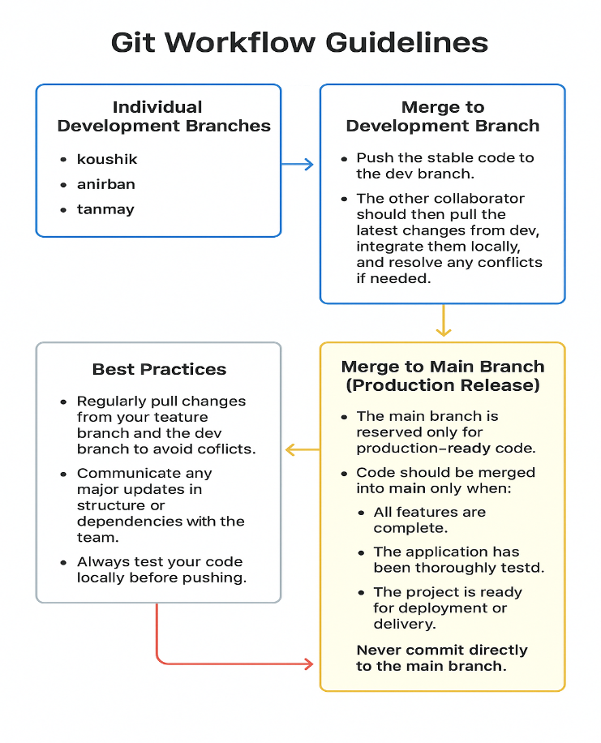

**🔄 Git Workflow Practice (with Different Accounts)**

Consider that **Koushik, Anirban, and Tanmay are developers (team members)** working on the same project.

**🔹 Setup**

1. **Each developer clones the repo** with their own GitHub account:

git init

git clone https://github.com/tanmayMt/benda-project-hiring-process.git

cd benda-project-hiring-process

1. **Set your username & email** (so commits are tracked correctly):

git config user.name "koushik"

git config user.email [koushik@example.com](mailto:koushik@example.com)

*(Each developer replaces with their own details: anirban, tanmay.)*

**✅ 2. Set up your branch (first time only)**

1. **Make sure you’re up to date with remote:**

**git fetch origin**

1. **Switch to the dev branch:**

**git checkout dev**

**git pull origin dev**

1. **Create and switch to your personal branch:**

**For Koushik:**

**git checkout -b koushik**

**For Anirban:**

**git checkout -b anirban**

**For Tanmay:**

**git checkout -b Tanmay**

**🔹 Round 1 – Personal Branch Work**

**Each developer will work in their own branch (koushik, anirban, tanmay).**

• **Koushik**

git checkout -b koushik

# make some changes

git add .

git commit -m "koushik: added feature A"

git push -u origin koushik

• **Anirban**

git checkout -b anirban

# make some changes

git add .

git commit -m "anirban: fixed bug B"

git push -u origin anirban

• **Tanmay**

git checkout -b tanmay

# make some changes

git add .

git commit -m "tanmay: updated UI"

git push -u origin tanmay

**🔹 Round 2 – Merge into dev**

1. **Each developer switches to dev:**

**git checkout dev**

**git pull origin dev**

**git merge koushik # (or anirban / tanmay depending on who is merging)**

**git push origin dev**

1. **Other developers pull latest dev and rebase their branch:**

**git checkout dev**

**git pull origin dev**

**git checkout your-branch**

**git rebase dev**

**🔹 Round 3 – Merge dev → main**

**After all features are tested in dev:**

**git checkout main**

**git pull origin main**

**git merge dev**

**git push origin main**

**✅ After completing these steps, you will have:**

* **Each developer’s feature in their branch.**
* **All features integrated into dev.**
* **A stable, production-ready main.**